EEP Annual Report for the EAZA Freshwater Teleost Taxon Advisory Group
Date of report: 04.07.22
1st Review date: 19.07.22
2nd Review date: 30.08.22
3rd Review date: 10.09.22
EEP Family name: Cyprinodontidae inc. Aphaniidae.
Coordinator name and Institution name: Alex Cliffe, ZSL Whipsnade Zoo
Supporters and collaborators’ names:
- Elmar Fienieg (EAZA)
- Baran Yoğurtçuoğlu (Ankara University, Turkey)
- Michael Koeck (Haus-de-Meeres)
- Anton Weissenbacher (Vienna)
- Christopher Martin (Berkley University, California)
- Amanda Guthrie (Head of Wildlife Services ZSL) and Simon Spiro (Wildlife Veterinary Pathologist ZSL)
List of species of priority within the EEP:
- Cyprinodon longidorsalis
- Cyprinodon veronicae
- Cyprinodon alvarezi
- Cyprinodon meeki
- Cyprinodon julimes
- Cyprinodon bobmilleri
- Aphanius transgrediens
- Aphanius danfordii
- Aphanius saldae
- Aphanius sirhani
- Aphanius apodus
Ex-situ status (list numbers of individuals, number of populations, held of each priority species in EAZA institutions and elsewhere (this could be private holders, other zoos/aquariums outside the EAZA region or not members), any issues (population losses, disease, etc), any new holders, any significant challenges or opportunities)
Cyprinodon longidorsalis
Institution | EAZA/Non-EAZA | Number | Action/Comments
Barneveld | Non EAZA | 0.0.25
Berlin Zoo | EAZA | 0.0.12
Brno Zoo | EAZA | 0.0.19
Chessington Sea Life | Non EAZA | 0.0.20 | Contact registrar as its ‘pending on ZIMS’
Koln Zoo | EAZA | 0.0.2
Munster Zoo | EAZA | 0.0.12
Ocean Journey, Denver | Non EAZA | N/A | Contact registrar as its ‘pending on ZIMS’
Rotterdam Zoo | EAZA | 0.0.23
San Antonio Zoo | Non EAZA | 0.0.51
Vienna Zoo | EAZA | 0.0.30
Whipsnade Zoo | EAZA | 0.0.119
TOTAL |  | 0.0.314 | 10 Active Institutions
Cyprinodon veronicae

Institution | EAZA/Non-EAZA | Number | Action/Comments
San Antonio Zoo | Non EAZA | 0.0.95
Steinhart Aquarium | Non EAZA | N/A | Contact registrar as its ‘pending on ZIMS’
The Deep | EAZA | N/A | Contact registrar as its ‘pending on ZIMS’
Vienna Zoo | EAZA | 0.0.30
Whipsnade Zoo | EAZA | 0.0.81
Berlin Aquarium | EAZA | 0.0.20
TOTAL |  | 0.0.226 | 4 Active Institutions

Cyprinodon alvarezi
Institution | EAZA/Non-EAZA | Number | Action/Comments
Vienna Zoo | EAZA | 0.0.30
Whipsnade Zoo | EAZA | 0.0.120
Palais de la Portedoree | EAZA | 10.10.0 | Pending transaction Q4 Sept 2022
TOTAL |  | 0.0.150 | 2 Active Institutions

Cyprinodon meeki
Institution | EAZA/Non-EAZA | Number | Action/Comments
Bristol Zoo | EAZA | 0.0.56
Whipsnade Zoo | EAZA | 0.0.150
TOTAL |  | 0.0.150 | 2 Active Institutions

Cyprinodon julimes
Institution | EAZA/Non-EAZA | Number | Action/Comments
 |  |  | No institutions found. Seek advice.
TOTAL |  | 0.0.0 | 0 Active Institutions

Cyprinodon bobmilleri
Institution | EAZA/Non-EAZA | Number | Action/Comments
Vienna Zoo | EAZA | 0.0.43 | Prioritise breeding and move a group
Aaron Ambos | Private | TBC | aambos@cox.net
Helsinki Sea Life | Non-EAZA | TBC | Awaiting confirmation of numbers (Sept 22)
TOTAL |  | 0.0.43 | 2 Active Institutions

Aphanius transgrediens
Institution | EAZA/Non-EAZA | Number | Action/Comments
Aquatis | N/A | 0.0.18 | Liaise with registrar on Aquatis location
Whipsnade Zoo | EAZA | 0.0.171
TOTAL |  | 0.0.189 | 2 Active Institutions

Aphanius danfordii

Institution | EAZA/Non-EAZA | Number | Action/Comments
Whipsnade Zoo | EAZA | 0.0.148
Berlin Aquarium | EAZA | 0.0.14
Bristol Zoo | EAZA | 0.0.30 | Move completed Aug 2022
TOTAL |  | 0.0.162 | 2 Active Institutions

Aphanius saldae
Institution | EAZA/Non-EAZA | Number | Action/Comments
Whipsnade Zoo | EAZA | 0.0.84 | Prioritise move
TOTAL |  | 0.0.84 | 1 Active Institution

Aphanius sirhani
Institution | EAZA/Non-EAZA | Number | Action/Comments
Vienna Zoo | EAZA | 0.0.10 | Prioritise breeding and move a group
Aquazoo, Dusseldorf | EAZA | 0.0.50 | Current breeding well
TOTAL |  | 0.0.60 | 2 Active Institution

Aphanius apodus
Institution | EAZA/Non-EAZA | Number | Action/Comments
Vienna Zoo | EAZA | 0.0.30 | Prioritise breeding and move a group
TOTAL |  | 0.0.30 | 1 Active Institution

In-situ status (list any IUCN Red List assessment updates for species, new threats, new collaborations, new projects/initiatives, funding received)
- Alex Cliffe contacted key colleagues that could help contribute to the best practice guidelines for pupfish. An option of creating a Microsoft Teams group and an accessible spreadsheet where colleagues can add key information to help build up a portfolio for each species.
- Amanda Guthrie (Head of Wildlife Services ZSL) and Simon Spiro (Wildlife Veterinary Pathologist ZSL) have joined the EEP as liaisons to support and advise on any veterinary and zoonotic elements that could support the best practice guidelines. Both will play an integral role due to the extensive knowledge, historical data and pathological expertise at ZSL; providing comprehensive assessments of both pupfish and killifish. A zoonosis appendix will be added to the pupfish guidelines.
- ZSL has formally recognised the Turkish Killifish, Aphanius transgrediens as a flagship species under their ‘Back from the Brink’ initiative. This platform will support species such as this through their conservation efforts and will help facilitate any in-situ projects.
- Alex Cliffe attended the IUCN CTSG (Conservation Translocation Specialist Group) course held at ZSL London Zoo May 2022. This training will help support the translocation of the Turkish Killifish, Aphanius transgrediens project in Turkey.
- Alex Cliffe attended a meeting with Dr Becca Young, Conservation Scientist – IUCN Green Status. This was an introduction to Green Status assessment and how this tool will be used for the Turkish Killifish, Aphanius transgrediens.
- Alex Cliffe attended the British Killifish Association Conference in Nottingham 16-18th Sept. This was to meet private collectors and look at what species are in the private sector but also to update attendees of
- Alex Cliffe will be going to Turkey (2nd Aug – 9th Aug 2022) to work with colleagues on the translocation work currently underway with the Turkish Government and Hacettepe University, Ankara. The plan of action is as follows:
  - Meet with Baran Yoğurtçuoğlu and assess university campus lake (Fig 1.) as a viable refugium for Aphanius transgrediens and to review the potential for the university to support the killifish in aquarium systems in their labs for research opportunities.

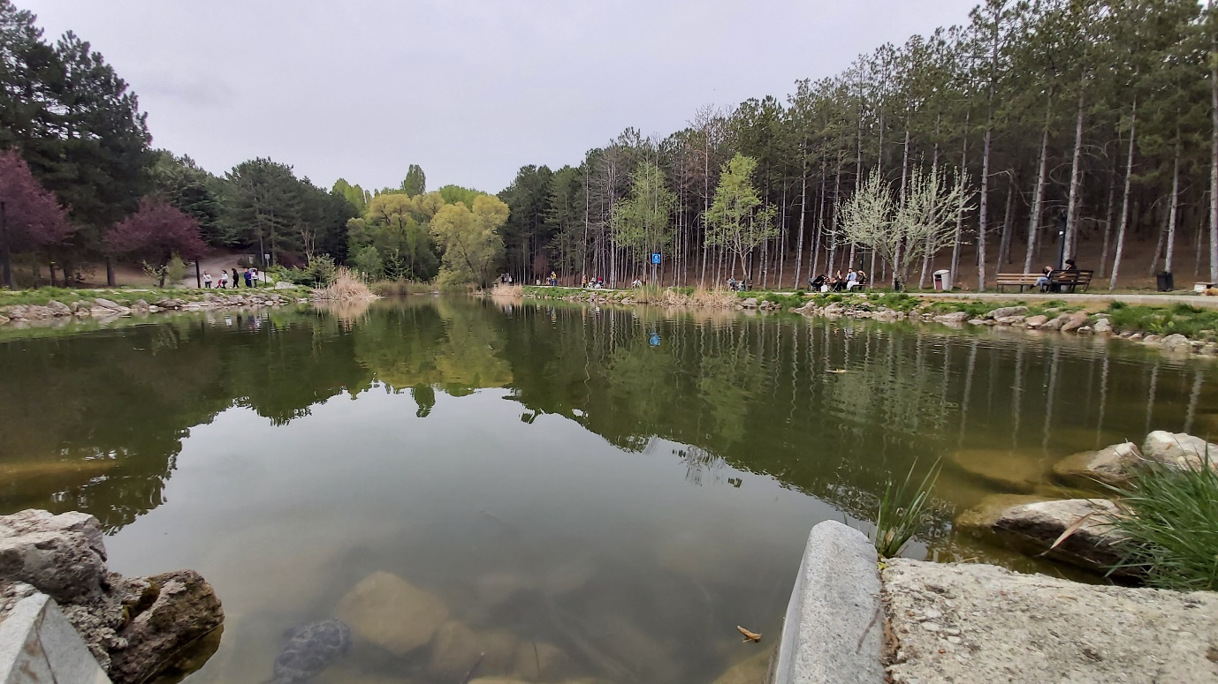
Fig. 1. Campus lake at Hacettepe University, Ankara (May 2022).
  - Visit Lake Acigol and conduct a survey of entire lake perimeter and assess current situation the sulphate mines north of the lake and gauge the current impact of the Gambusia holbrooki.
  - Visit the Turkish government’s ornamental fish facility in Antalya where they have collected around 400 Aphanius transgrediens to provide a robust breeding population for future translocation work. Alex to assess facility but also to formalise a Disease Risk Assessment plan for the facility. Contact has already been made with the ZSL Institute of Zoology to support any pathology guidance from historical work at ZSL. (Fig 2-4)

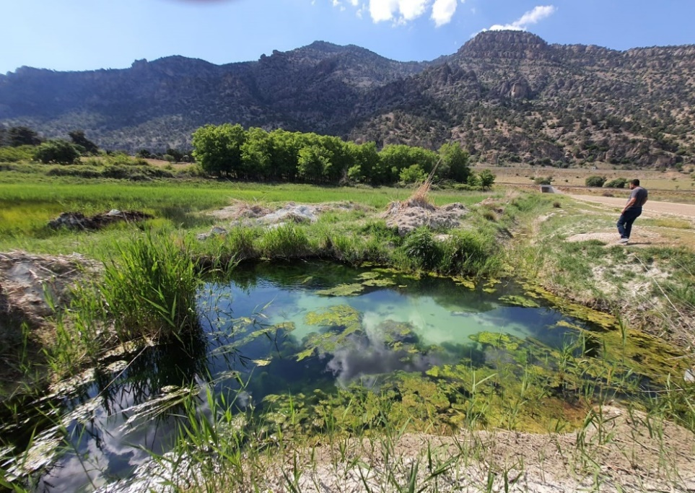
Fig 2. A spring at Lake Acigol (May 2022).
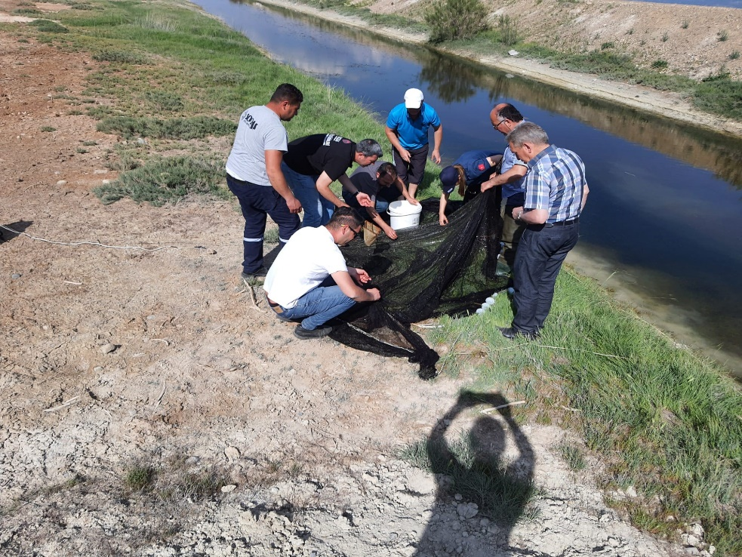
Fig. 3. Collecting Aphanius transgrediens from Lake Acigol May 2022.

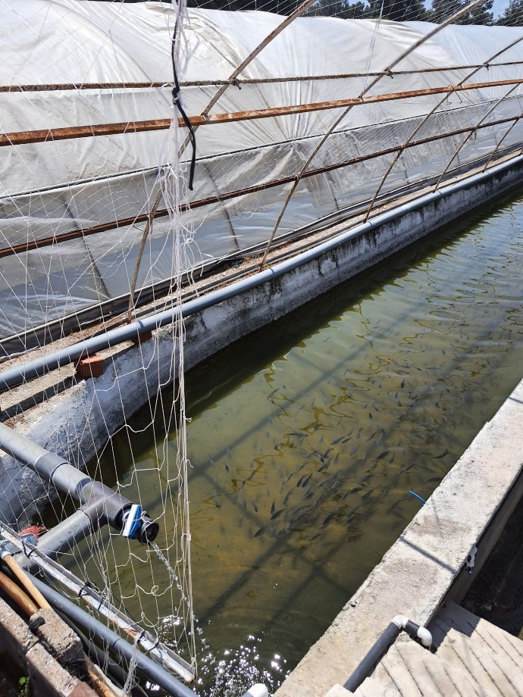
Fig 4. Potential outdoor pools for Aphanius transgrediens at Antalya breeding facility.

Acigol killifish survey update Aug 2022:
Following on from the recent work that Turkish colleagues conducted in May 2022. The fieldwork in Aug 2022 with Alex Cliffe and Baran Yoğurtçuoğlu provided some up-to-date information on the status of the species along with meeting with key contacts in both Ankara and Antalya.
Alex Cliffe conducted fieldwork surveys with Assistant Professor Baran Yoğurtçuoğlu (Hacettepe University) in Turkey to assess the status of the Critically Endangered Acigol killifish, Aphanius transgrediens. Visit was in three parts.

1. Visited Hacettepe University, Ankara to meet with Turkey's leading hydrologist and Ichthyologists on the current status of Lake Acigol and the new pressures on the ecosystem (Fig 5). We have now been informed that drilling will be taking place to abstract a high mineral and super saline pocket under the lake which is believed to be five times the strength of seawater. This could have a catastrophic impact on the habitat.

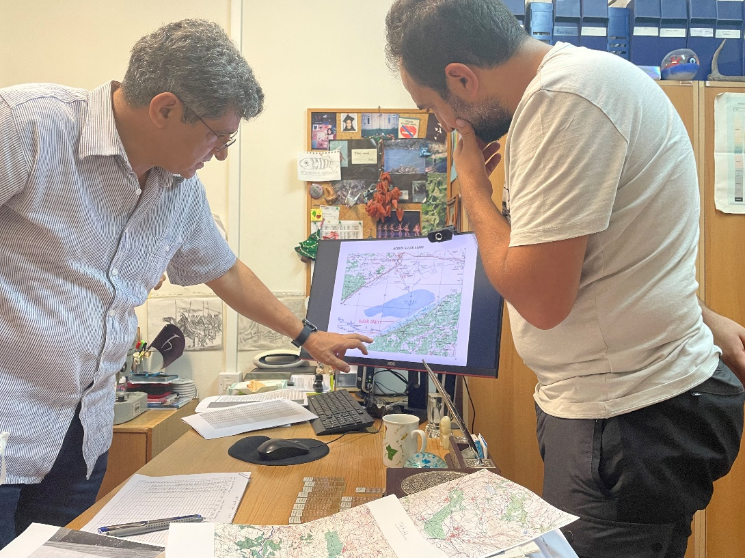

Fig 5. Baran Yoğurtçuoğlu and Turkey’s leading hydrologist, Mehmet Ekmeci

The University campus contains a small lake with an ideal habitat for the A.transgrediens. (Fig 6). This is a potential option of assisted migration to house a population here as a contingency but also to support any potential research within the campus. A water quality assessment revealed that this habitat would be suitable for homing the killifish in the future (Fig 7).

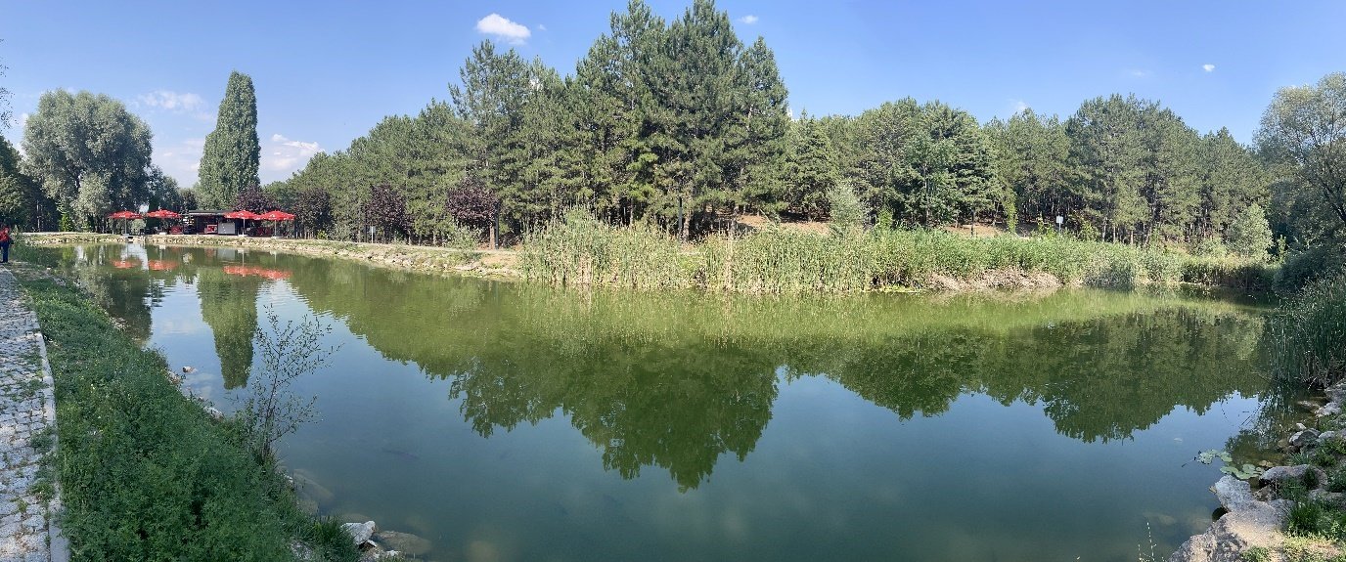
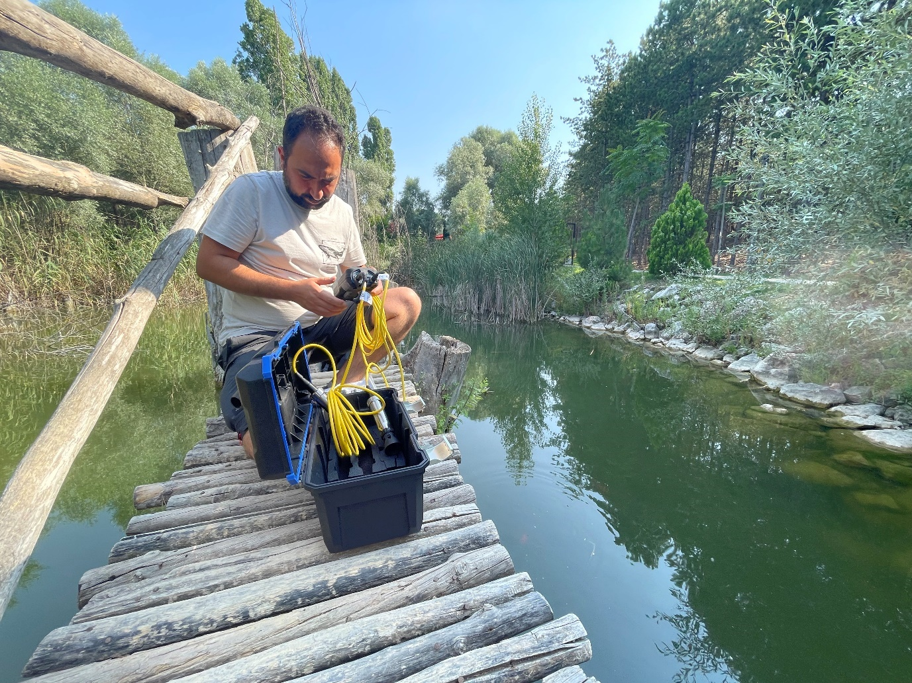
Fig 6. University campus lake for potential homing of A.transgrediens

Fig 7. Baran Yoğurtçuoğlu analysing the water quality of the

2. Conducted the most comprehensive survey ever conducted of Lake Acigol, covering over 20 locations (Fig 8). It was evident that the killifish has been restricted even further down to one tributary south of the lake (Fig 9) but in high numbers and a small population on the northern area next to the salt flats. High numbers of the invasive mosquitofish Gambusia holbrooki and increasing pressures from water abstraction, pollution and salt mining. Healthy meetings with the managers of the salt refineries to ensure there is a good rapport with university colleagues to gain access to restricted areas when necessary.
Fig 8. Survey locations around Lake Acigol.

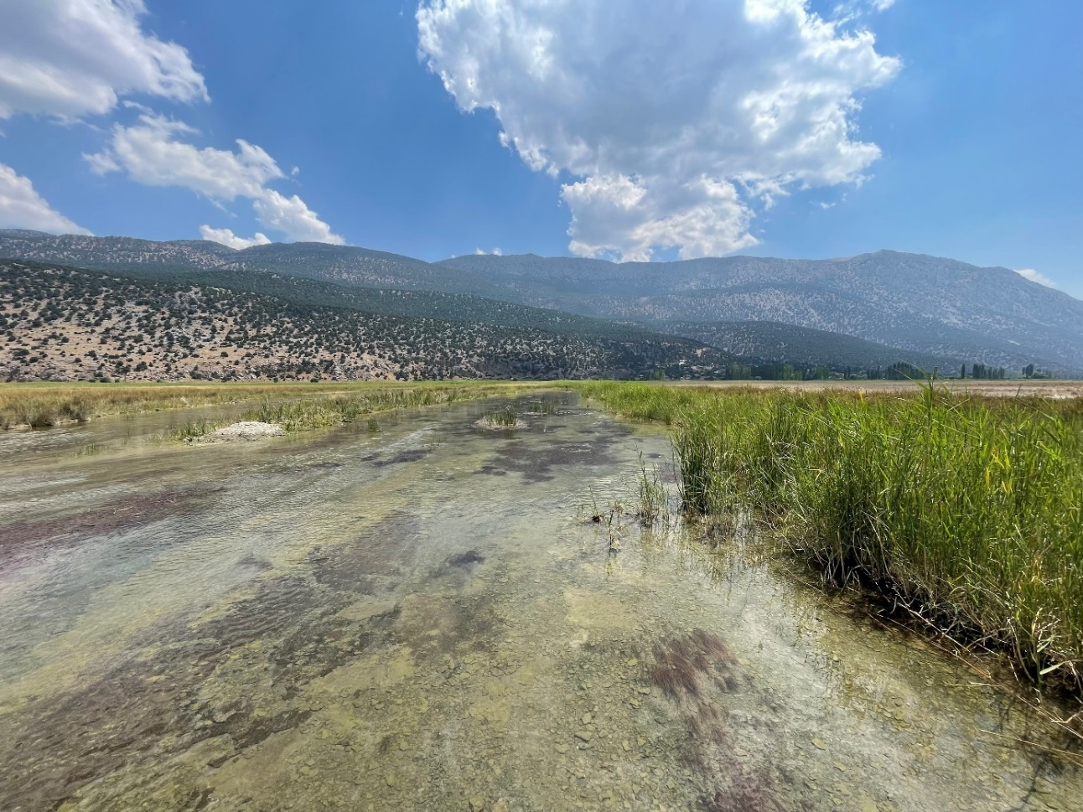

Fig 9. Prime location for the largest population of A. transgrediens at the south tributary of Lake Acigol.
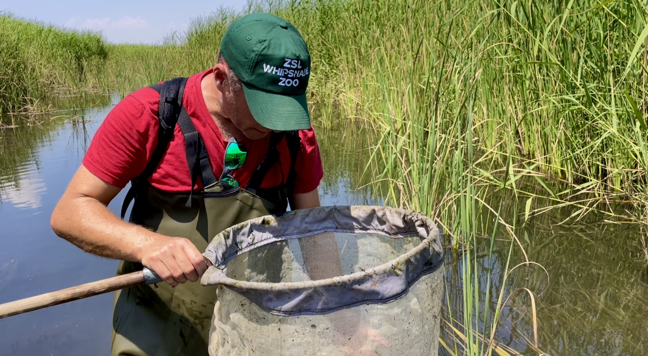
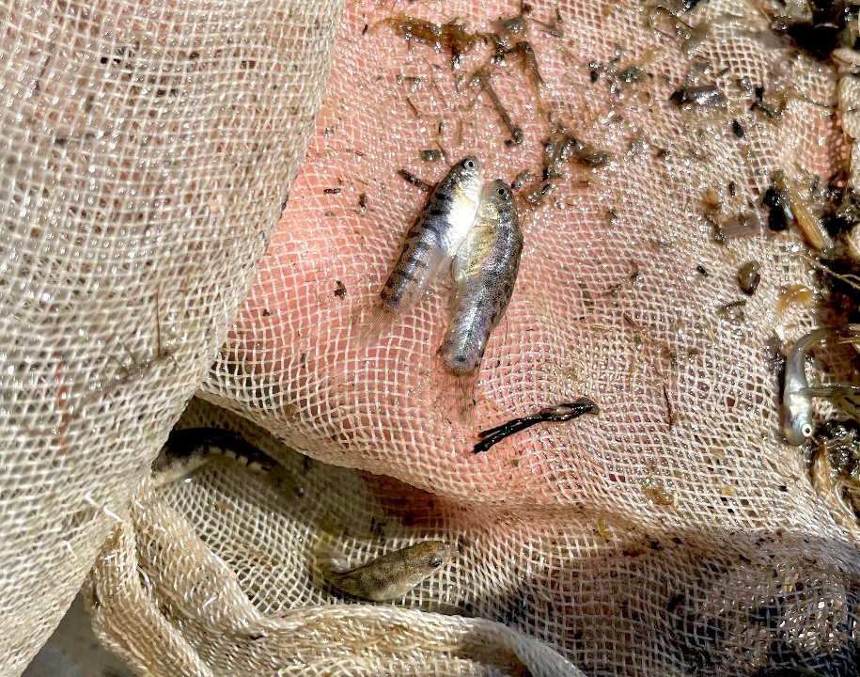

Fig 10. Male A.transgrediens (left) and female (right)

Fig 11. Alex Cliffe finding the first A.transgrediens of the fieldwork trip

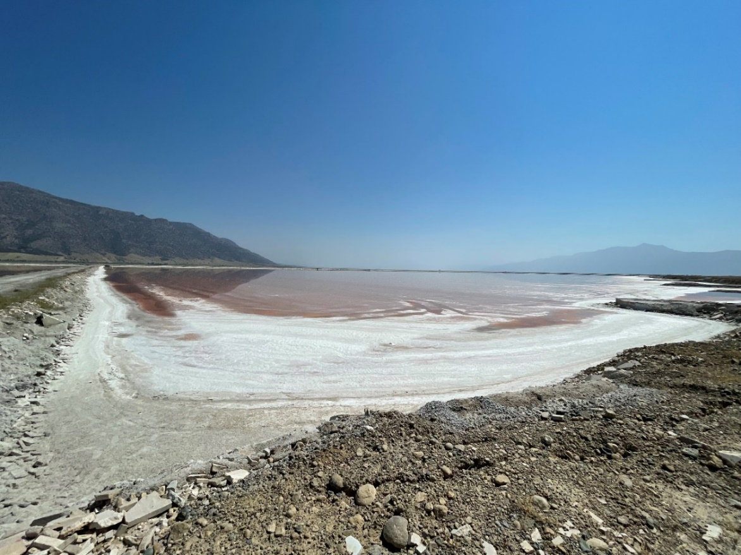

Fig 12. Salt flats north of Lake Acigol having a impact on salt level into the lake.

3. Met with the Directors of the Fisheries and Aquaculture in Antalya to discuss the translocation plans for the killifish (Fig 12 & 13). Their facility is around 3 hectares in size supporting large scale production of ornamental fish (Fig 14) but agreed to house and breed the endemic killifish for potential reintroduction (Fig 15). Discussions on possible funding routes and cryopreservation options to support the work within the facility. Alex Cliffe gave advice on breeding techniques and housing for the killifish to maximise spawning potential.
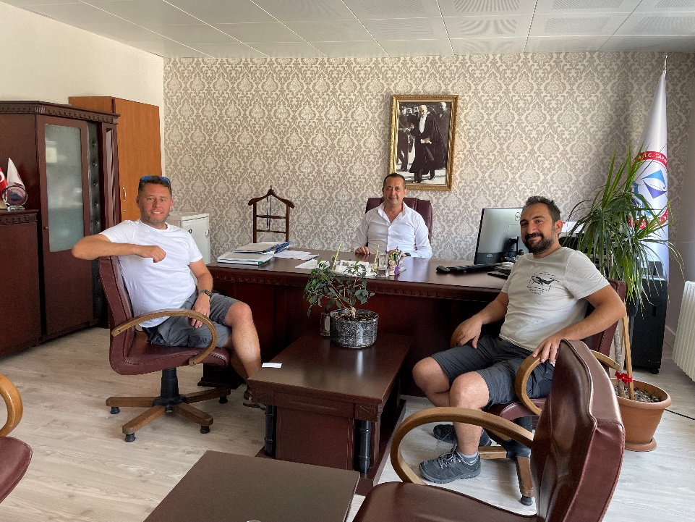

Fig 12. Alex Cliffe and Baran Yoğurtçuoğlu meeting with Fisheries of Aquaculture Director, Mehmet Kanyilmaz in Ankara
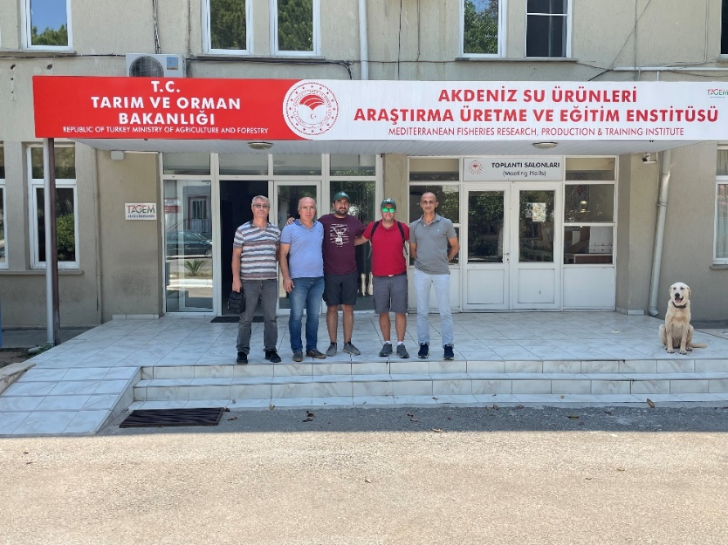

Fig 13. Alex Cliffe and Baran Yoğurtçuoğlu meeting with Fisheries managers at the Antalya aquaculture facility.

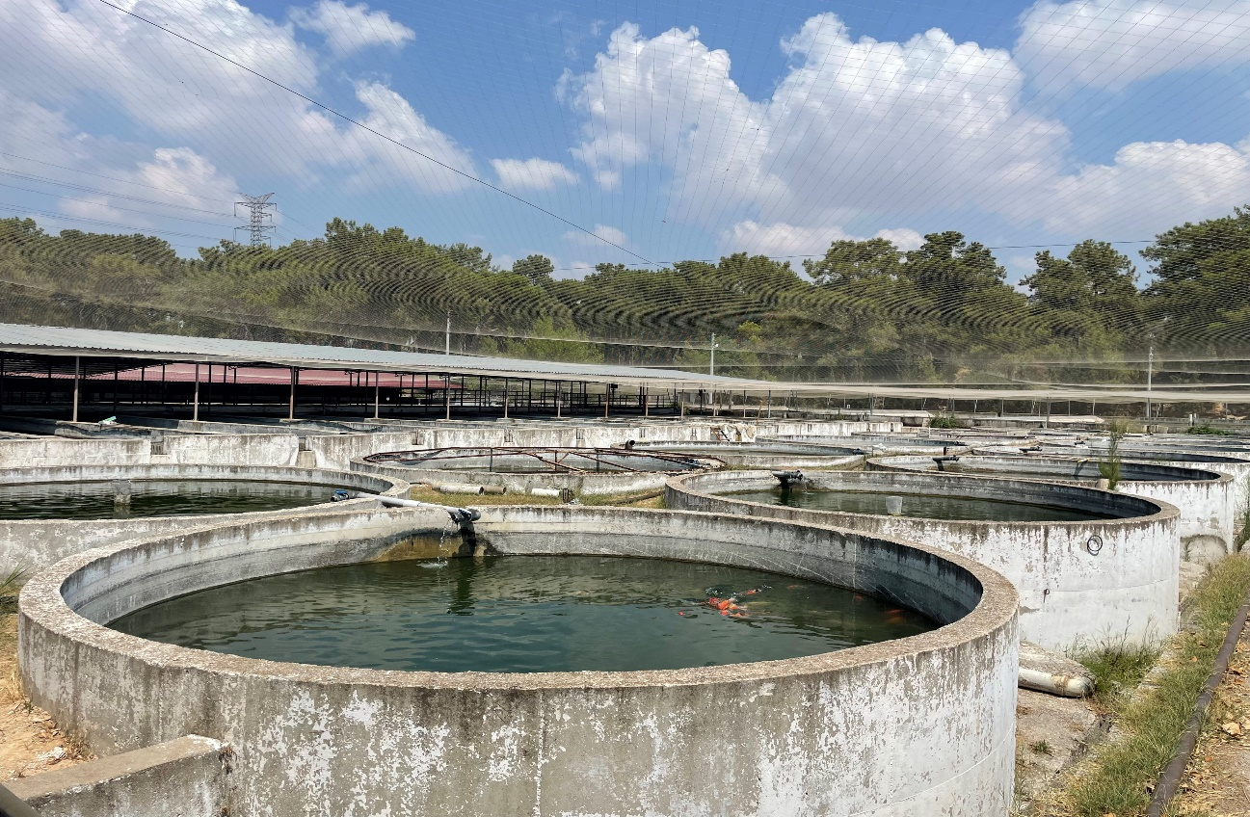
Fig 14. Outdoor aquaculture ponds at the aquaculture facility.

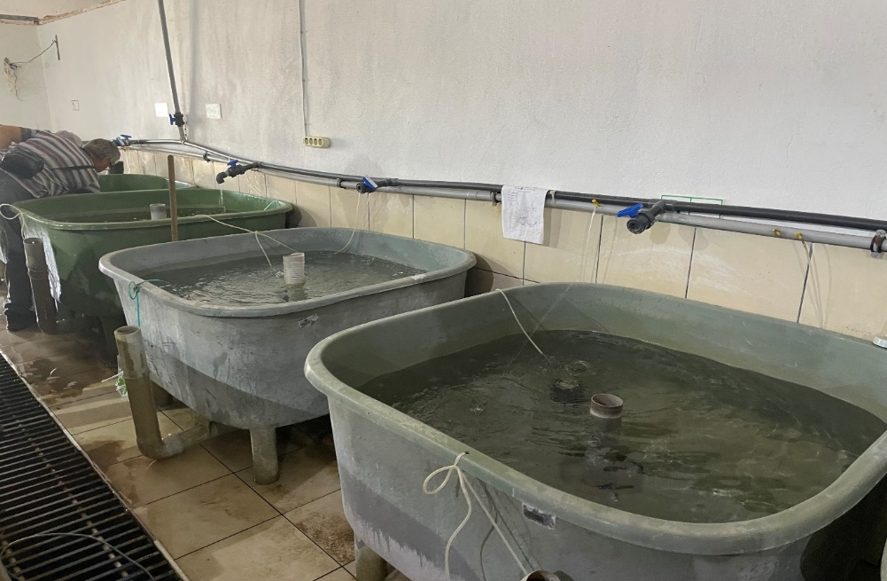

Fig 15. Vats housing the A.transgrediens at the facility in Antalya

In summary, the following actions need to be considered:

- The killifish seems to be more restricted in range which elevates the urgency to conduct more surveys throughout the year in 2023.
- Compile a report of the fieldwork
- Follow up funding options with Fisheries in Antalya.
- Network with zoos across Turkey to get involved with this project, potentially housing the species and using their respective institution as a platform for education and possible research. Liaise with Faruk Yalcin Zoo (EAZA) in Istanbul to look at supporting this killifish in their institution due to previous work with ZSL and Hacettepe University.
- Redesign an exhibit at ZSL Whipsnade Zoo for the Acigol killifish and use the resources obtained from the fieldwork as engaging interpretation.
News: new species, new project, etc

Case study: (could be new information such as breeding success, method, husbandry improvements, details of new species discovered or named..
- Reclassification of the Turkish killifish genus from Aphanius to Anatolichthys Anatolichthys - Killifische Info is still pending. Awaiting confirmation through IUCN Red Listing.
- Alex Cliffe attended a Teams meeting (May 2022) with Chris Martin, Berkley University, and other US colleagues on the Cyprinodontidae Working Group to review the status of pupfish in private collections and zoos/aquariums with an accessible website to centralise a refined inventory. Chris also stated that he will be visiting multiple pupfish sites in Mexico in July 2022 and will feed back on his visit. Various colleagues have already highlighted that the drought situation has got worse which is having direct impacts on many of the springs.
- Alex Cliffe has been using the Michael Schneider pupfish mineral mix with key pupfish and killifish species with great results. Species such as Aphanius transgrediens, Cualac tessellatus and Aphanius danfordii were not breeding successfully so the mineral additions were used with positive results. This recipe has been adapted for all pupfish and killifish species at ZSL.
- ZSL Whipsnade Zoo completed a research project with ZSL Institute of Zoology on way vinyl projected on the Bluetail Goodea, Ataeniobius toweri. Primarily to look at the promotion of natural behaviours with the potential of expanding this to pupfish and killifish species. The final report has been completed and awaiting final submission for review.

Photo: one or two of a species or event related to the family

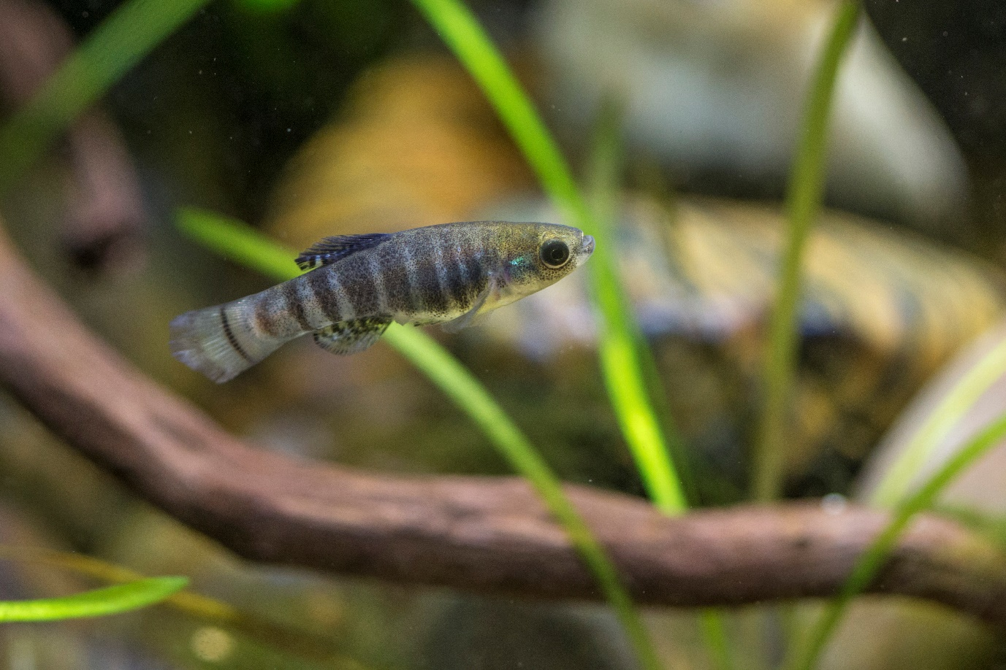
Male Aphanius transgrediens

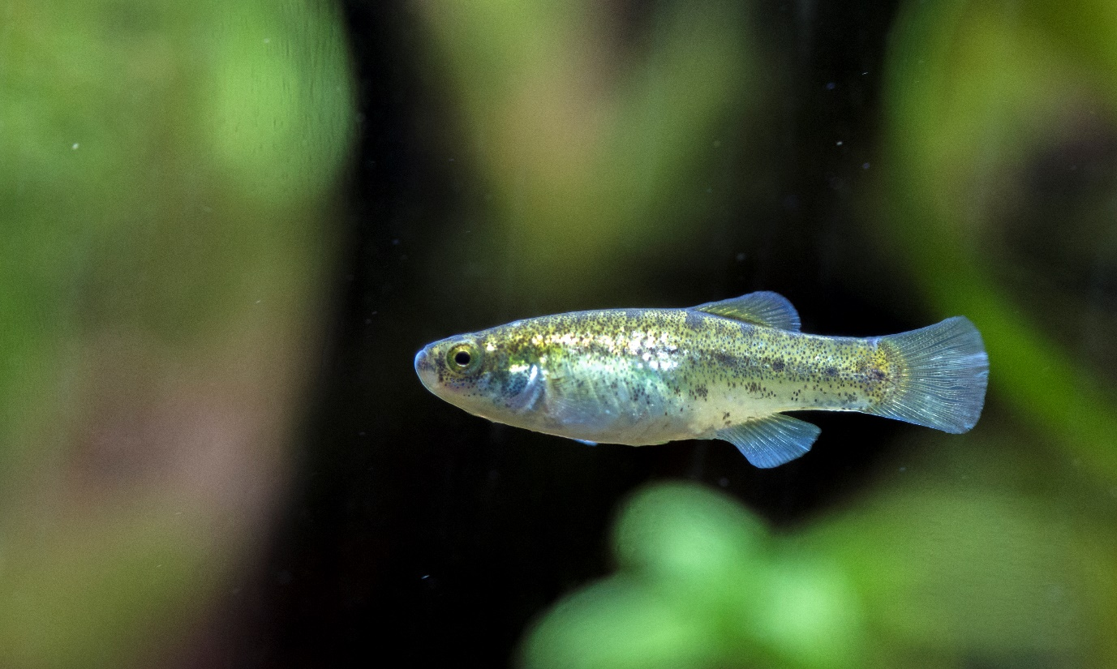
Female Aphanius transgrediens

LEFT Aphanius saldae (Female top/Male bottom). RIGHT Aphanius fontinalis (Female top/Male bottom)

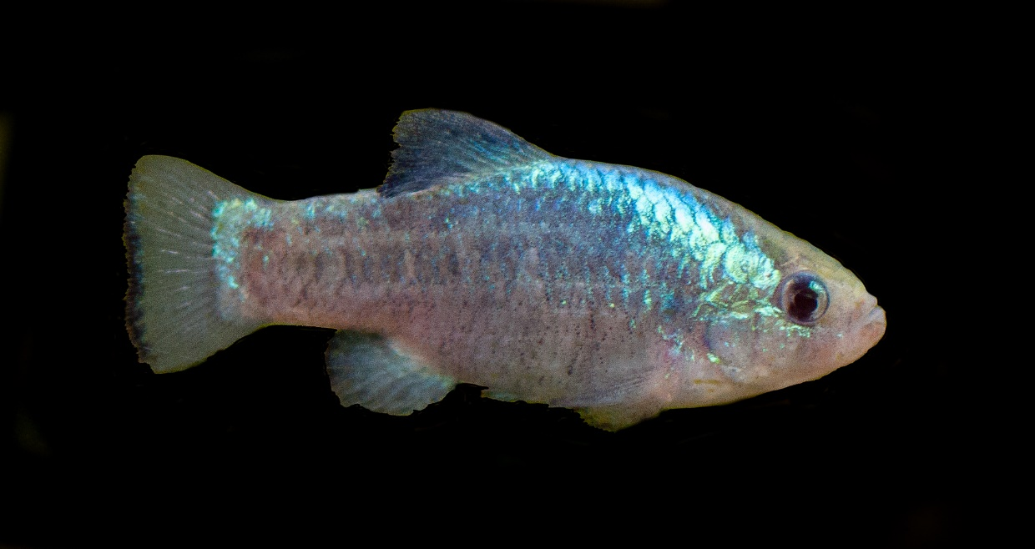
Male Cyprinodon meeki
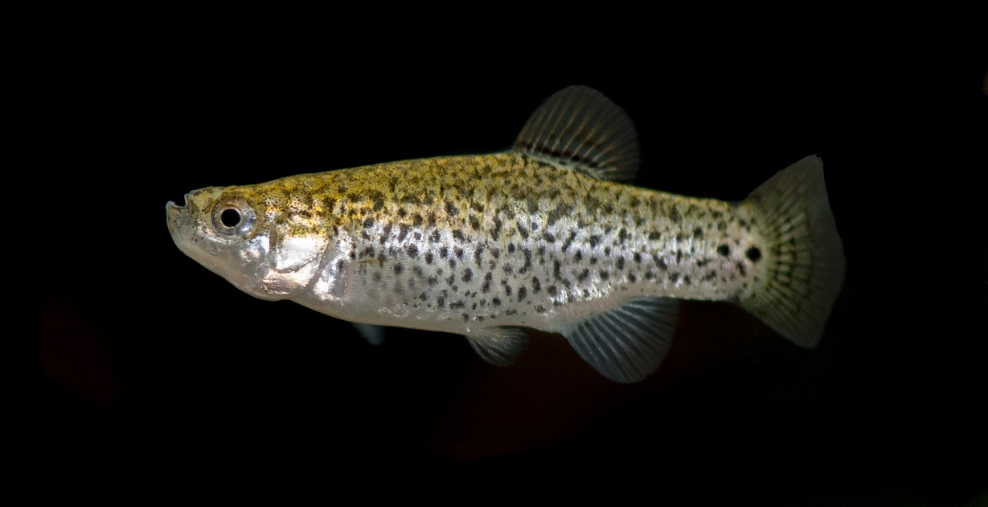
Female Aphanius danfordii
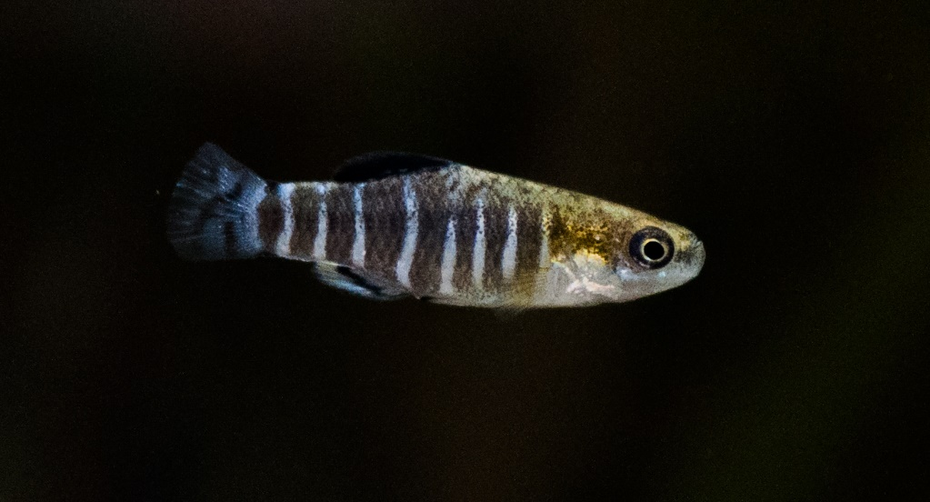
Male Aphanius danfordii

